Template for the DS Assignment 2 – part 2

Please note that you can modify this template to suit your own presentation

This is only a sample, you should make sure all aspects of your work and assessment tasks are clearly evidenced

You should check Assignment Deliverables and the marking schema.

Take screenshots showing clearly:

- Student id in Apex account
- Apex 5 – university www address
- Time and date on your machine
E.g.
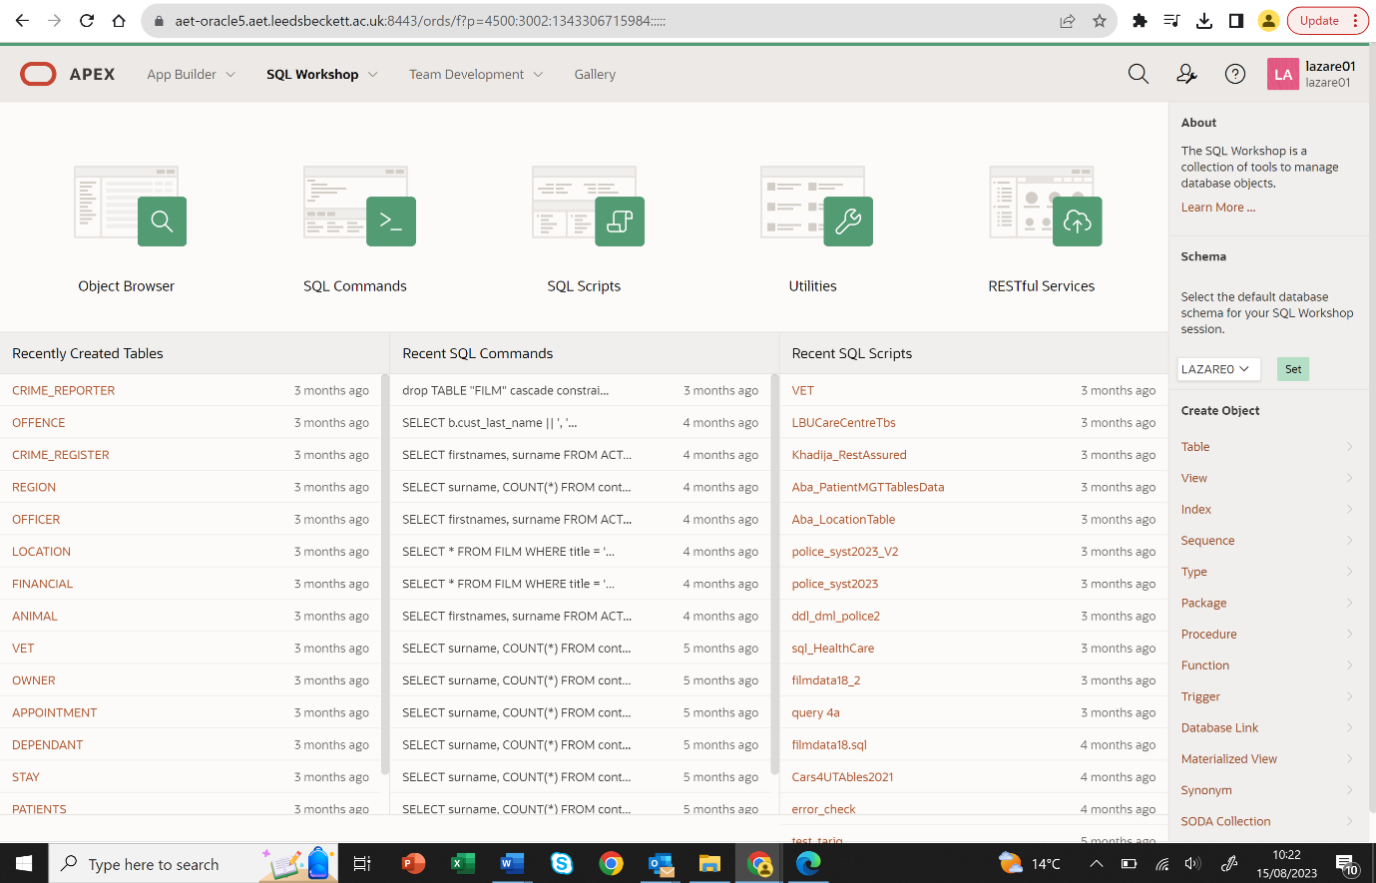
2
1
3
Title:
Module Name: Database System
Student Name: Sushan Bhandari
Student id:77356704

Contents
Task 5. Application Builder Forms 5
Example: Forms Page (note yours should be Master/Detail) 5
INSERT: A new customer record inserted: 6
DELETE: e.g. a customer record has been deleted: 6
UPDATE: e.g. a customer record has been changed: 7
In this table change customer name dudsh as sushan 7
Form1 7
Form2 8
Form 3 8
Form4 9
Form5 9
Apex Features: LOV, Dynamic Actions, Validation 9
This is audit1 12
This is audit part 2 15
This is audit part 3 18
Date maintenance (batch update) 21
4. Bibliography 22
5. Appendixes 23

Before you start, read Assessment Guide carefully. Check Marking schema and Assignment Deliverables.

Task 5. Application Builder Forms

Example: Forms Page (note yours should be Master/Detail)

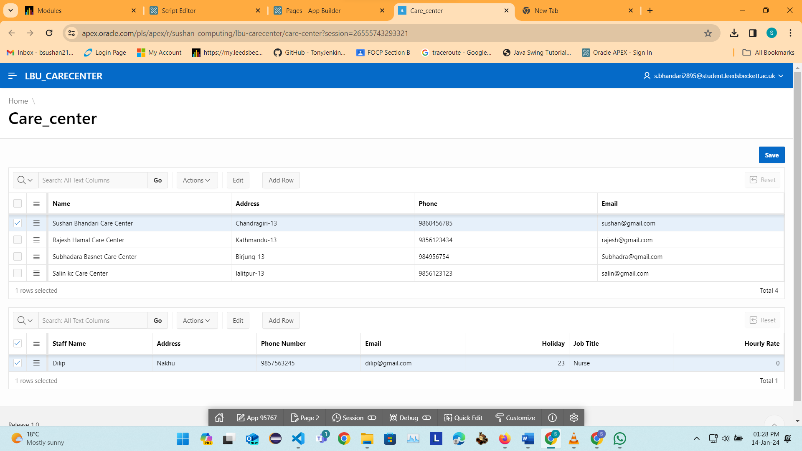

INSERT: A new customer record inserted:

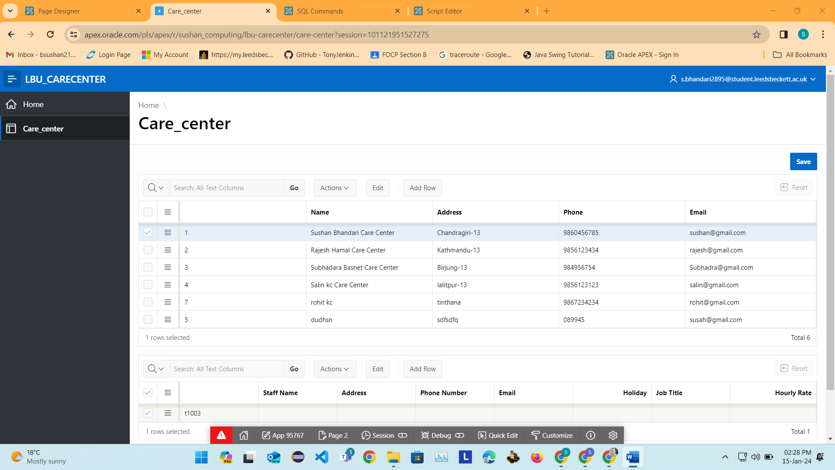

In this table care_center, rohit kc customer is added

DELETE: e.g. a customer record has been deleted:

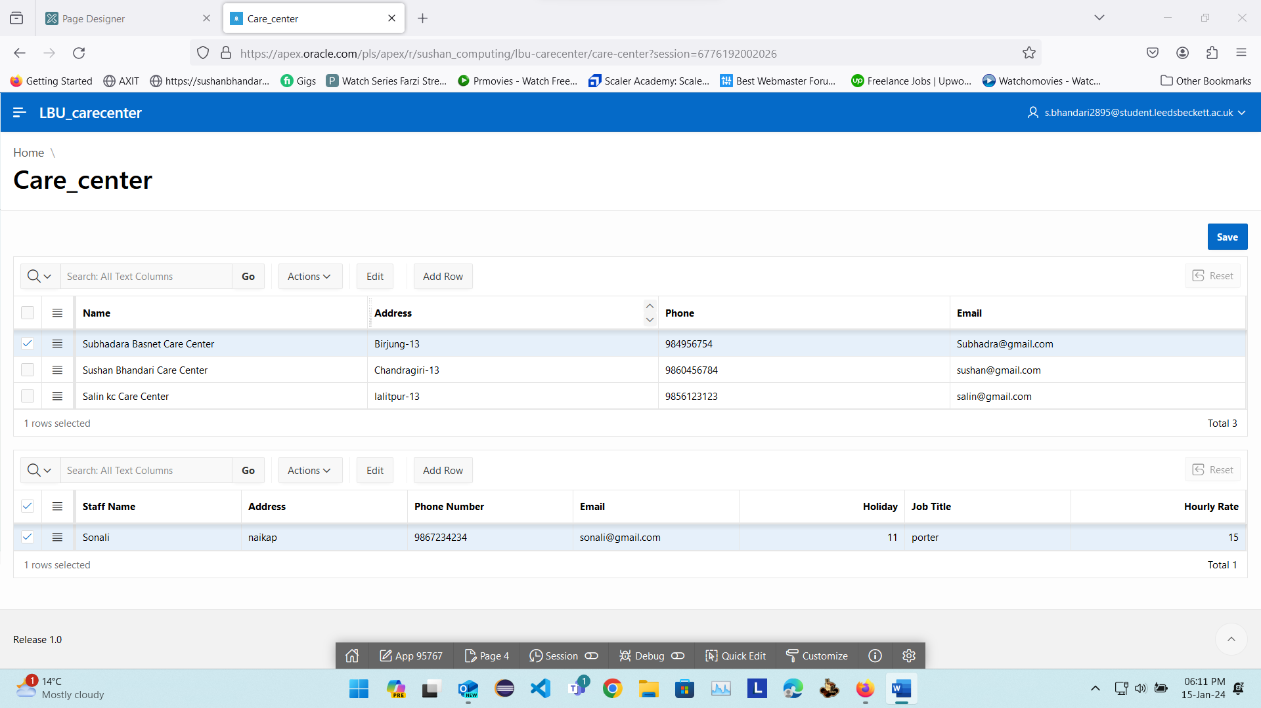
In this table rajesh hamal care cennter has been deleted.

UPDATE: e.g. a customer record has been changed:

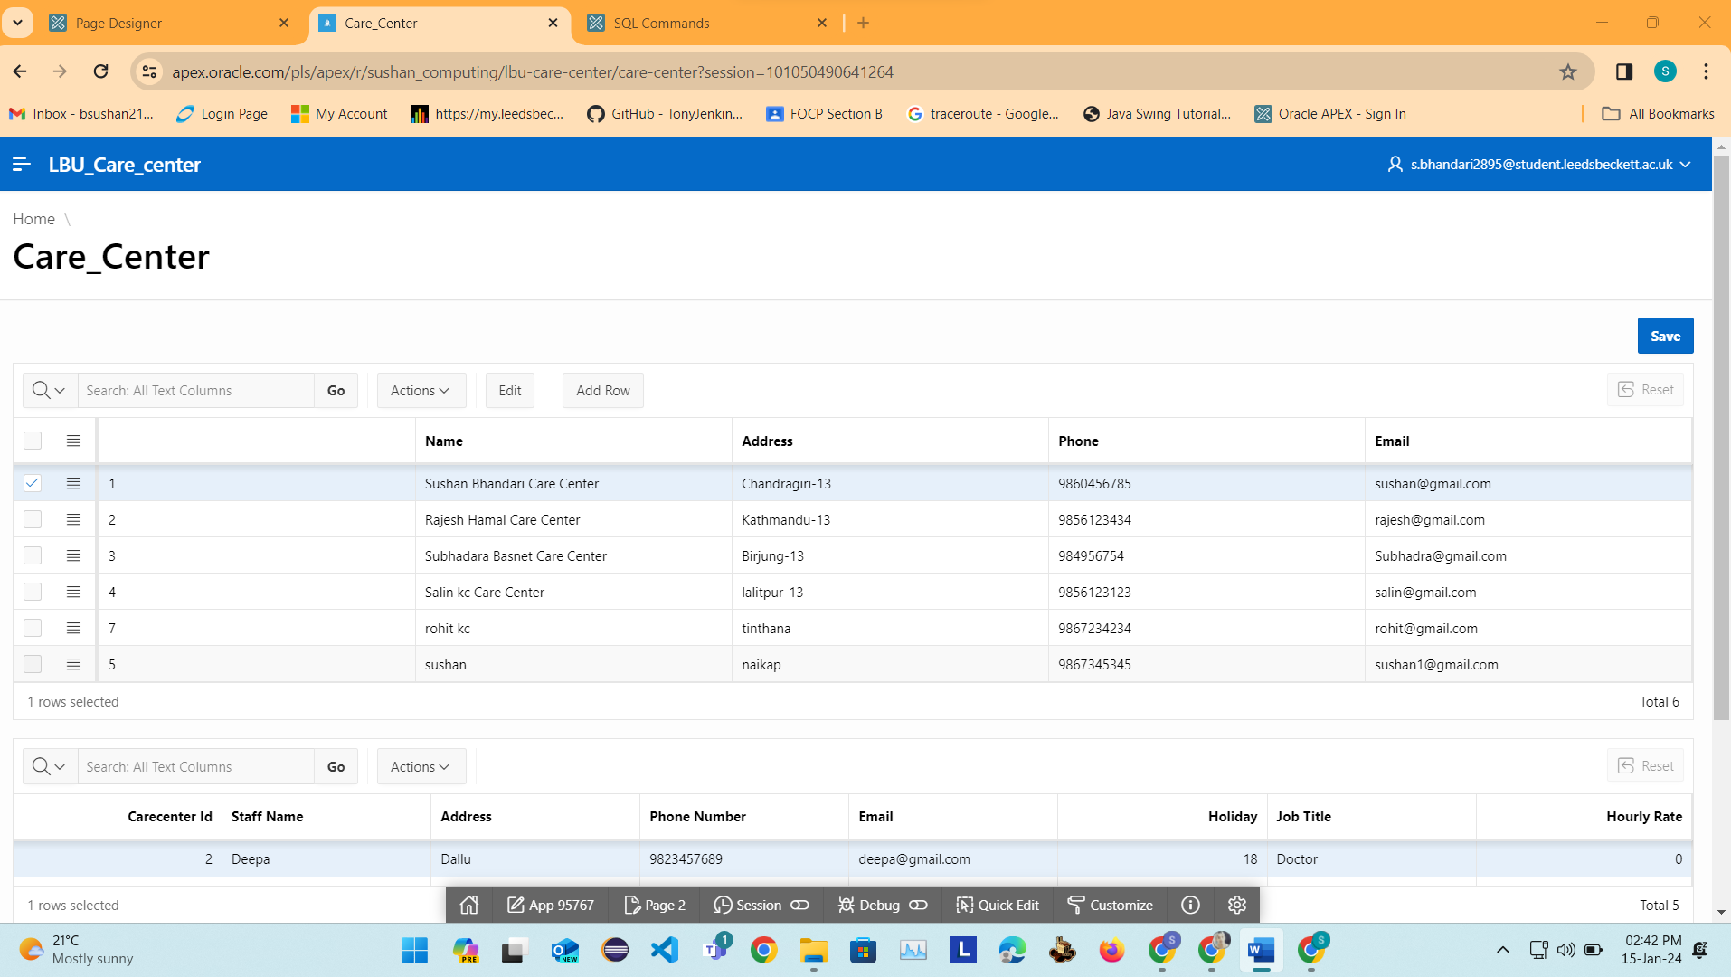

In this table change customer name dudsh as sushan

Form1

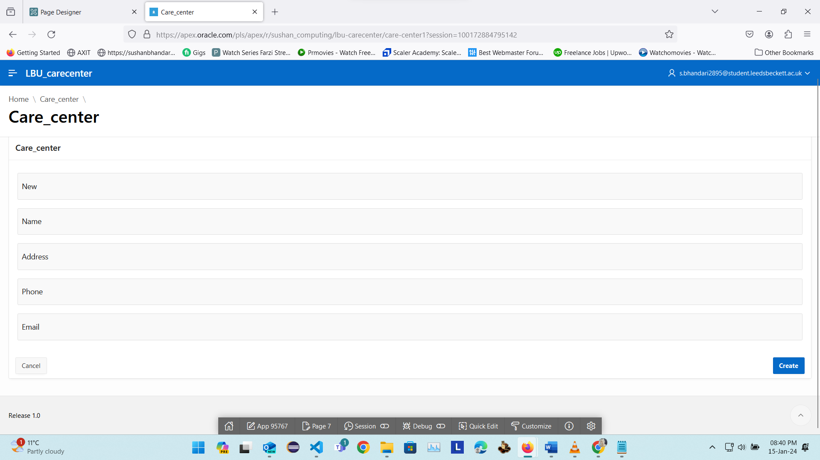

Form2

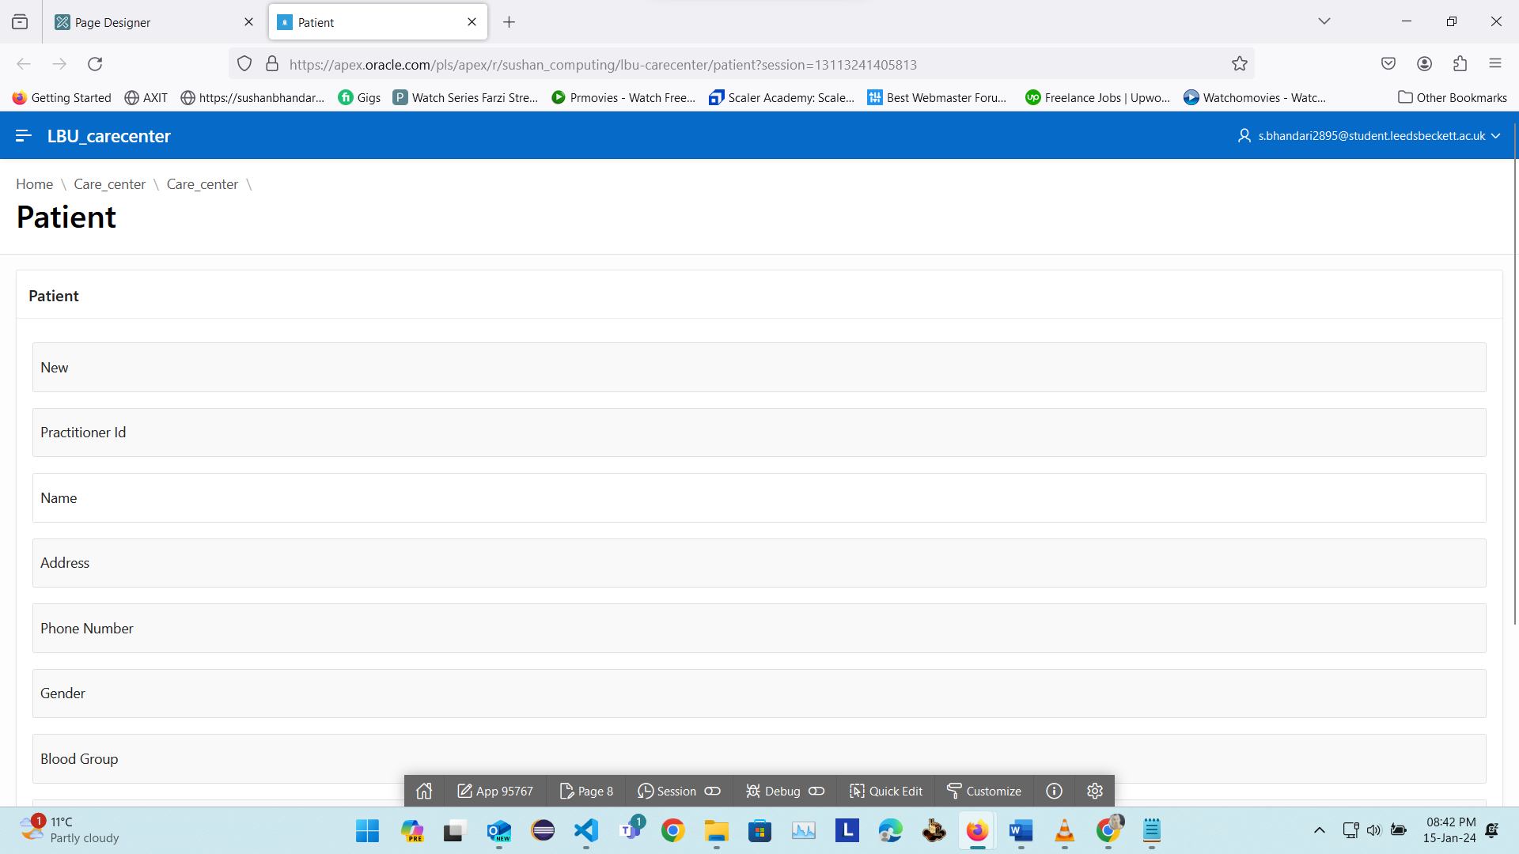

Form 3

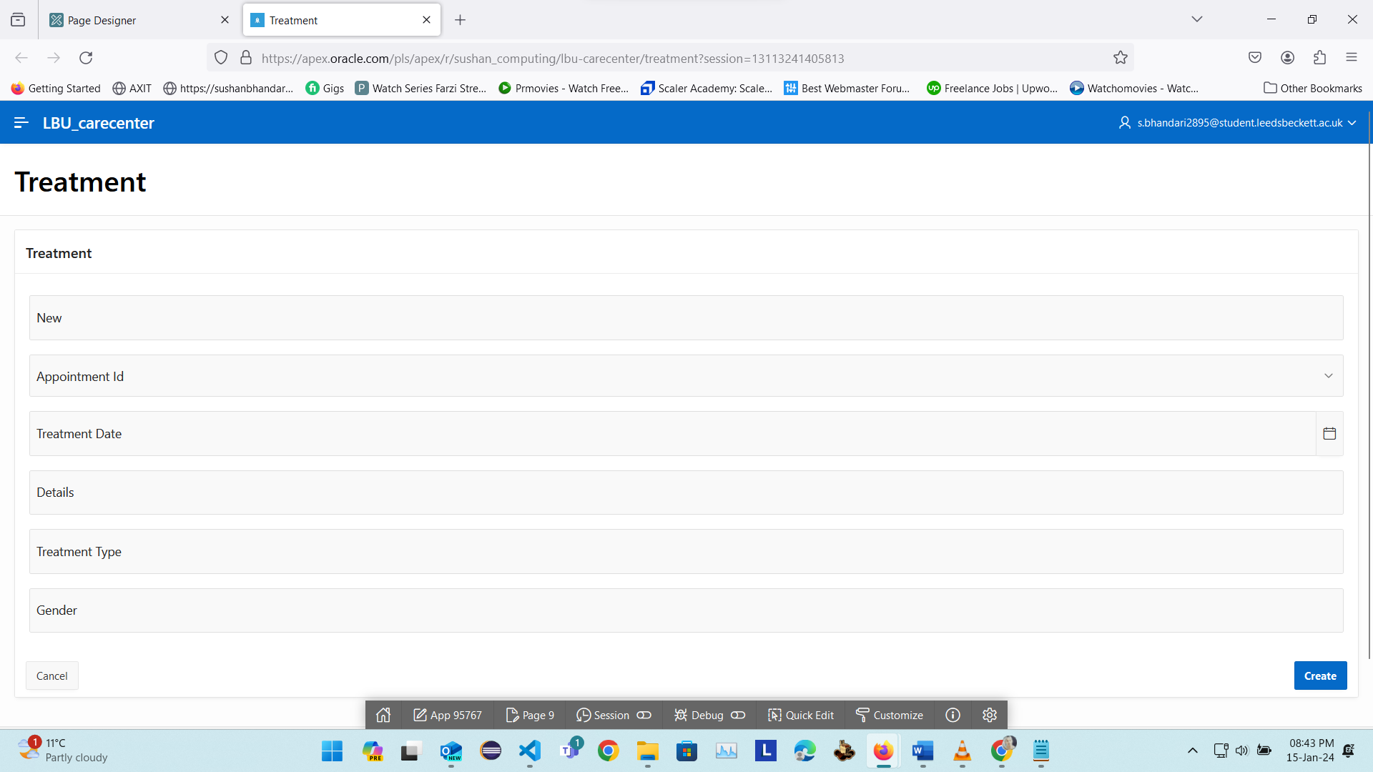

Form4

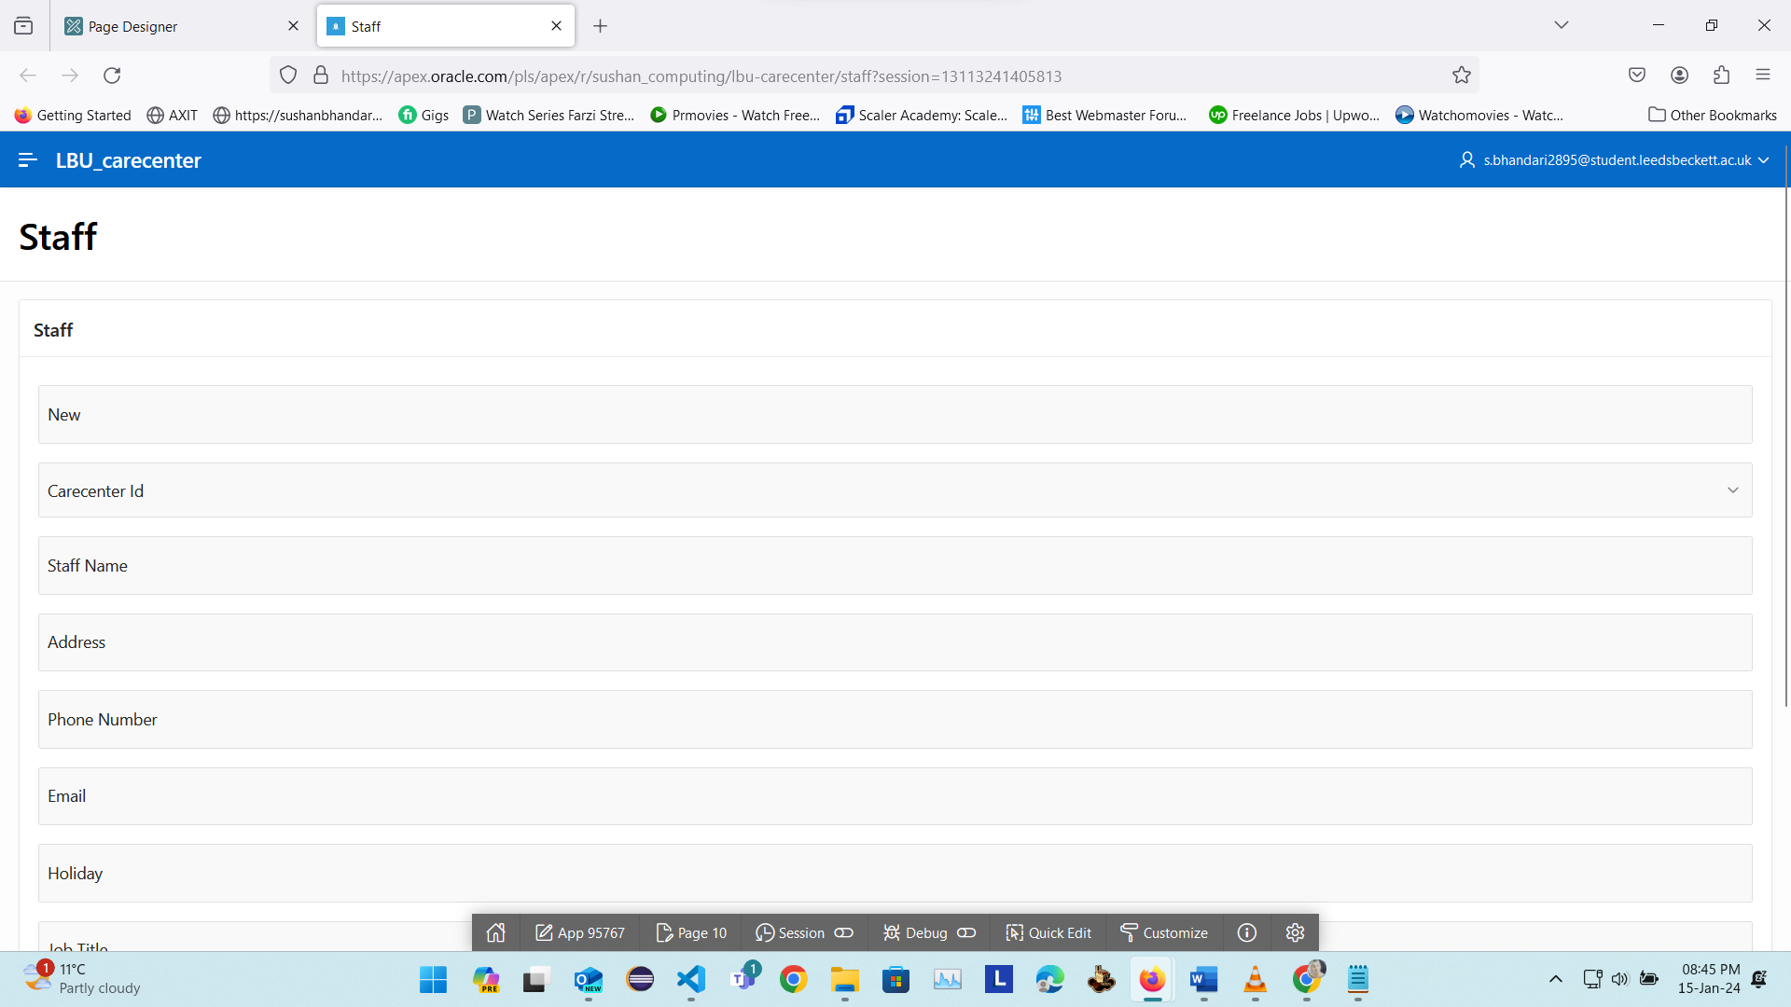

Form5

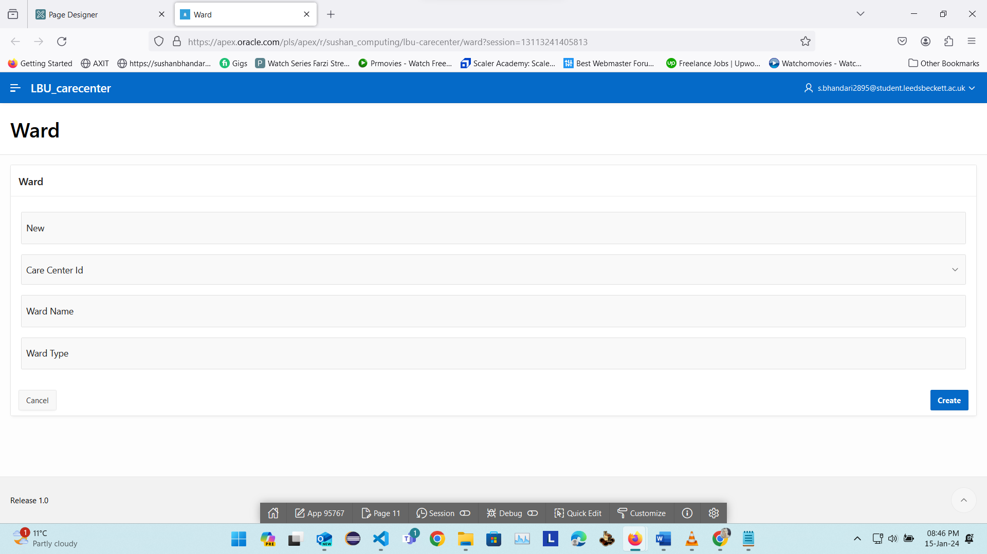

Apex Features: LOV, Dynamic Actions, Validation
For this part you will first need to decide which of the key database areas will be the emphasis of your database solution. Select one of the options below:
- The security of your data by implementing server and client-side solutions (e.g., User log in, password hashing, audit of user tables and data).
- Importance of programming, validations and other Apex features to ensure data quality.
- Data maintenance (batch updates) of an existing DB system.

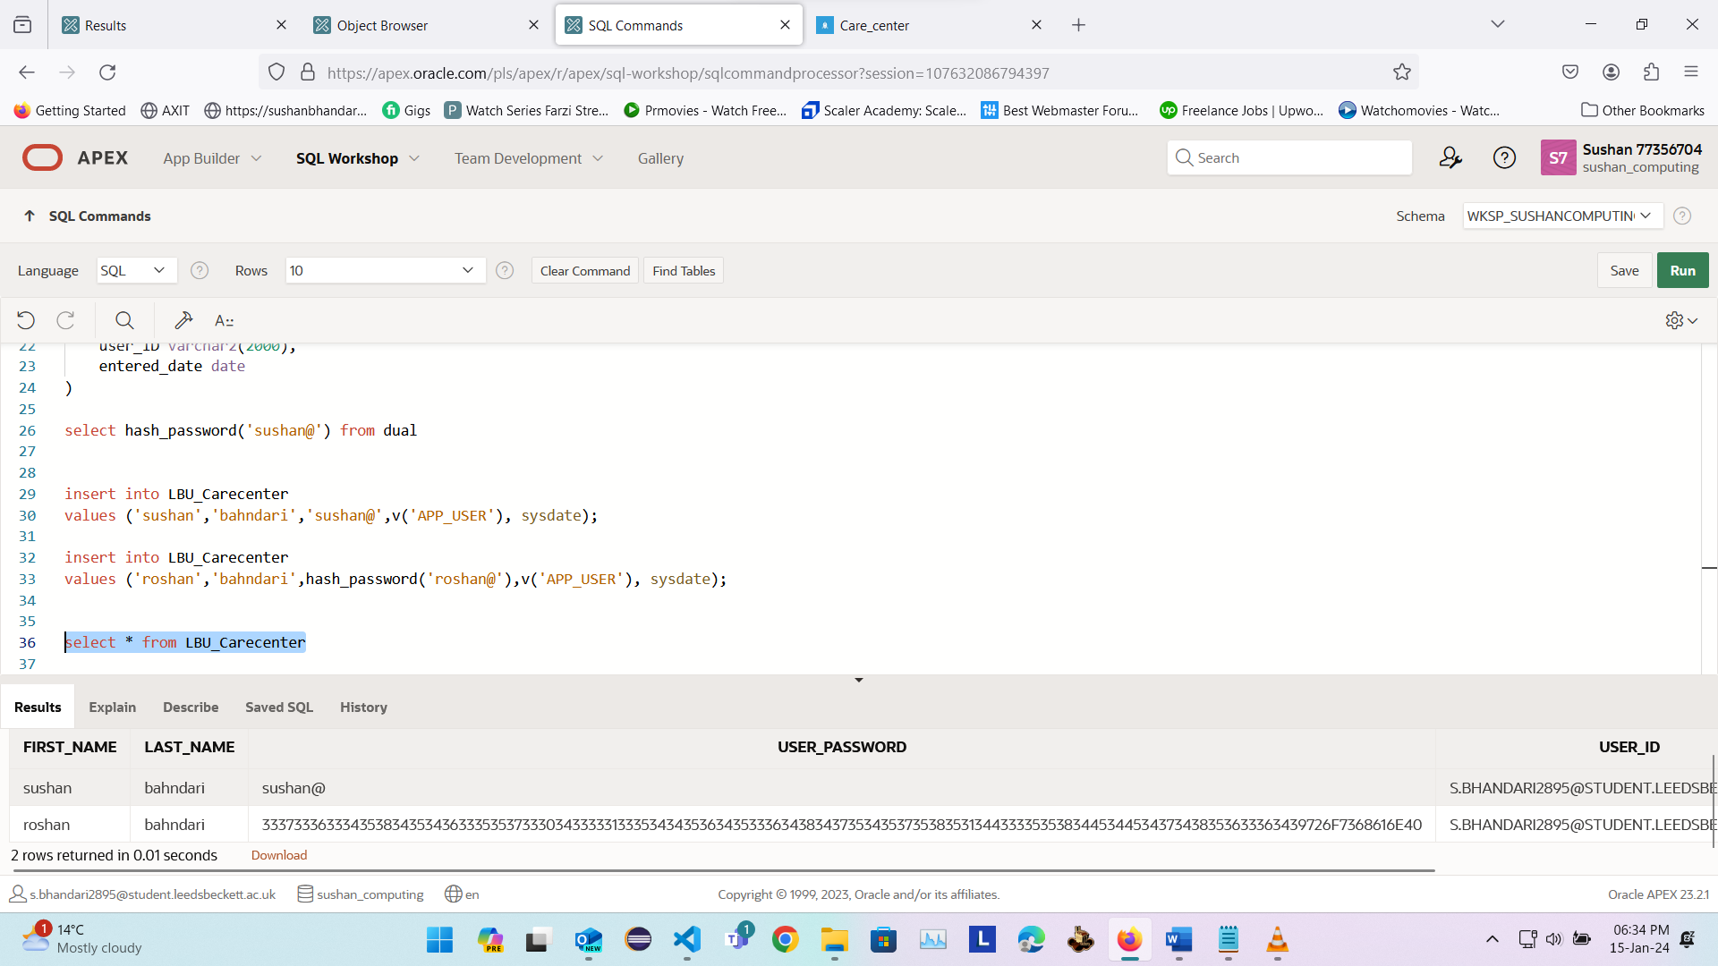

CREATE OR REPLACE FUNCTION hash_password(p_password IN VARCHAR2) RETURN VARCHAR2 IS
l_salt RAW(2000) := UTL_RAW.CAST_TO_RAW(DBMS_RANDOM.STRING('X', 32));
l_hash RAW(2000);
BEGIN
-- Hash the password with the salt using SHA-256 algorithm
l_hash := UTL_RAW.CAST_TO_RAW(l_salt || p_password);

dbms_output.put_line ('l_hash : '||l_hash);
-- Convert the hashed result to a hexadecimal string
RETURN RAWTOHEX(l_hash);
END hash_password;
/

create table LBU_Carecenter
(
first_name varchar2(20),
last_name varchar2(20),
user_password varchar2(4000),
user_ID varchar2(2000),
entered_date date
)

select hash_password('sushan@') from dual

insert into LBU_Carecenter
values ('sushan','bahndari','sushan@',v('APP_USER'), sysdate);

insert into LBU_Carecenter
values ('roshan','bahndari',hash_password('roshan@'),v('APP_USER'), sysdate);

select * from LBU_Carecenter

This is audit1

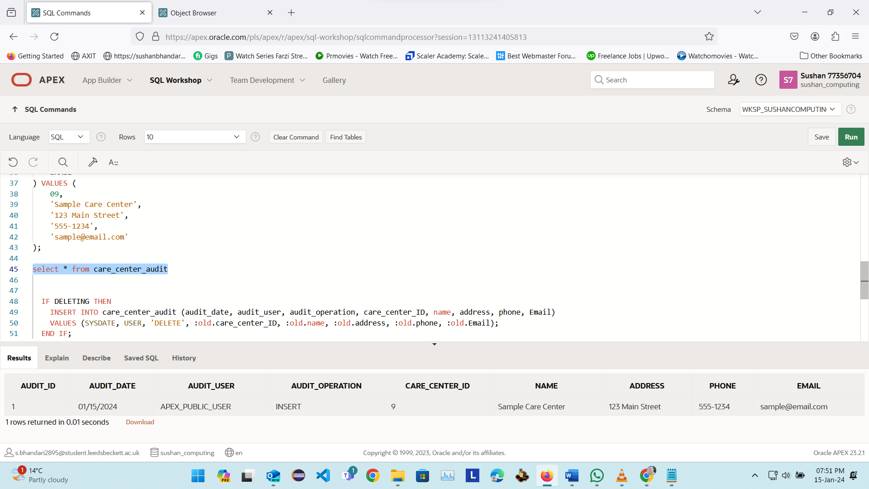

CREATE OR REPLACE TRIGGER trig_audit_care_center
BEFORE INSERT ON care_center_audit
FOR EACH ROW
DECLARE
vAuditID NUMBER(5);
BEGIN
SELECT MAX(NVL(Audit_ID, 0)) + 1 INTO vAuditID FROM care_center_audit;

IF vAuditID IS NULL THEN
:NEW.Audit_ID := 1;
ELSE
:NEW.Audit_ID := vAuditID;
END IF;
END;
/

CREATE OR REPLACE TRIGGER trigger_CARE_CENTER_audit_trial
AFTER INSERT OR UPDATE OR DELETE ON CARE_CENTER
FOR EACH ROW
BEGIN
IF INSERTING THEN
INSERT INTO care_center_audit (audit_date, audit_user, audit_operation, care_center_ID, name, address, phone, Email)
VALUES (SYSDATE, USER, 'INSERT', :new.care_center_ID, :new.name, :new.address, :new.phone, :new.Email);
END IF;

IF UPDATING THEN
INSERT INTO care_center_audit (audit_date, audit_user, audit_operation, care_center_ID, name, address, phone, Email)
VALUES (SYSDATE, USER, 'UPDATE', :old.care_center_ID, :old.name, :old.address, :old.phone, :old.Email);
END IF;

INSERT INTO CARE_CENTER (
CARE_CENTER_ID,
NAME,
ADDRESS,
PHONE,
EMAIL
) VALUES (
09,
'Sample Care Center',
'123 Main Street',
'555-1234',
'sample@email.com'
);

select * from care_center_audit

IF DELETING THEN
INSERT INTO care_center_audit (audit_date, audit_user, audit_operation, care_center_ID, name, address, phone, Email)
VALUES (SYSDATE, USER, 'DELETE', :old.care_center_ID, :old.name, :old.address, :old.phone, :old.Email);
END IF;
END;
/

This is audit part 2
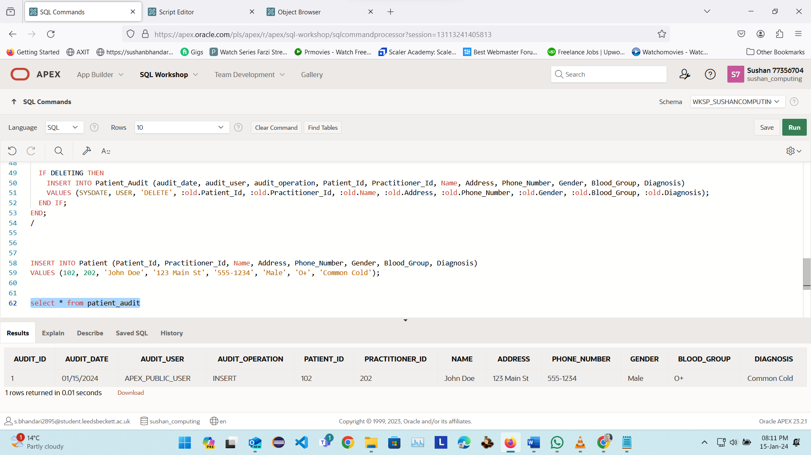
CREATE TABLE Patient_Audit (
Audit_Id NUMBER,
AUDIT_DATE date,
AUDIT_USER varchar2(20),
AUDIT_OPERATION varchar2(20),
Patient_Id NUMBER,
Practitioner_Id NUMBER,
Name VARCHAR2(50),
Address VARCHAR2(100),
Phone_Number VARCHAR2(15),
Gender VARCHAR2(10),
Blood_Group VARCHAR2(5),
Diagnosis VARCHAR2(50)
);

CREATE OR REPLACE TRIGGER trig_audit_patient
BEFORE INSERT ON Patient_Audit
FOR EACH ROW
DECLARE
vAuditID NUMBER(5);
BEGIN

SELECT MAX(NVL(Audit_ID, 0)) + 1 INTO vAuditID FROM Patient_Audit;

IF vAuditID IS NULL THEN
:NEW.Audit_ID := 1;
ELSE
:NEW.Audit_ID := vAuditID;
END IF;
END;
/

CREATE OR REPLACE TRIGGER trigger_patient_audit_trial
AFTER INSERT OR UPDATE OR DELETE ON Patient
FOR EACH ROW
BEGIN
IF INSERTING THEN
INSERT INTO Patient_Audit (audit_date, audit_user, audit_operation, Patient_Id, Practitioner_Id, Name, Address, Phone_Number, Gender, Blood_Group, Diagnosis)
VALUES (SYSDATE, USER, 'INSERT', :new.Patient_Id, :new.Practitioner_Id, :new.Name, :new.Address, :new.Phone_Number, :new.Gender, :new.Blood_Group, :new.Diagnosis);
END IF;

IF UPDATING THEN
INSERT INTO Patient_Audit (audit_date, audit_user, audit_operation, Patient_Id, Practitioner_Id, Name, Address, Phone_Number, Gender, Blood_Group, Diagnosis)
VALUES (SYSDATE, USER, 'UPDATE', :old.Patient_Id, :old.Practitioner_Id, :old.Name, :old.Address, :old.Phone_Number, :old.Gender, :old.Blood_Group, :old.Diagnosis);
END IF;

IF DELETING THEN
INSERT INTO Patient_Audit (audit_date, audit_user, audit_operation, Patient_Id, Practitioner_Id, Name, Address, Phone_Number, Gender, Blood_Group, Diagnosis)
VALUES (SYSDATE, USER, 'DELETE', :old.Patient_Id, :old.Practitioner_Id, :old.Name, :old.Address, :old.Phone_Number, :old.Gender, :old.Blood_Group, :old.Diagnosis);
END IF;
END;
/

INSERT INTO Patient (Patient_Id, Practitioner_Id, Name, Address, Phone_Number, Gender, Blood_Group, Diagnosis)
VALUES (102, 202, 'John Doe', '123 Main St', '555-1234', 'Male', 'O+', 'Common Cold');

select * from patient_audit

This is audit part 3
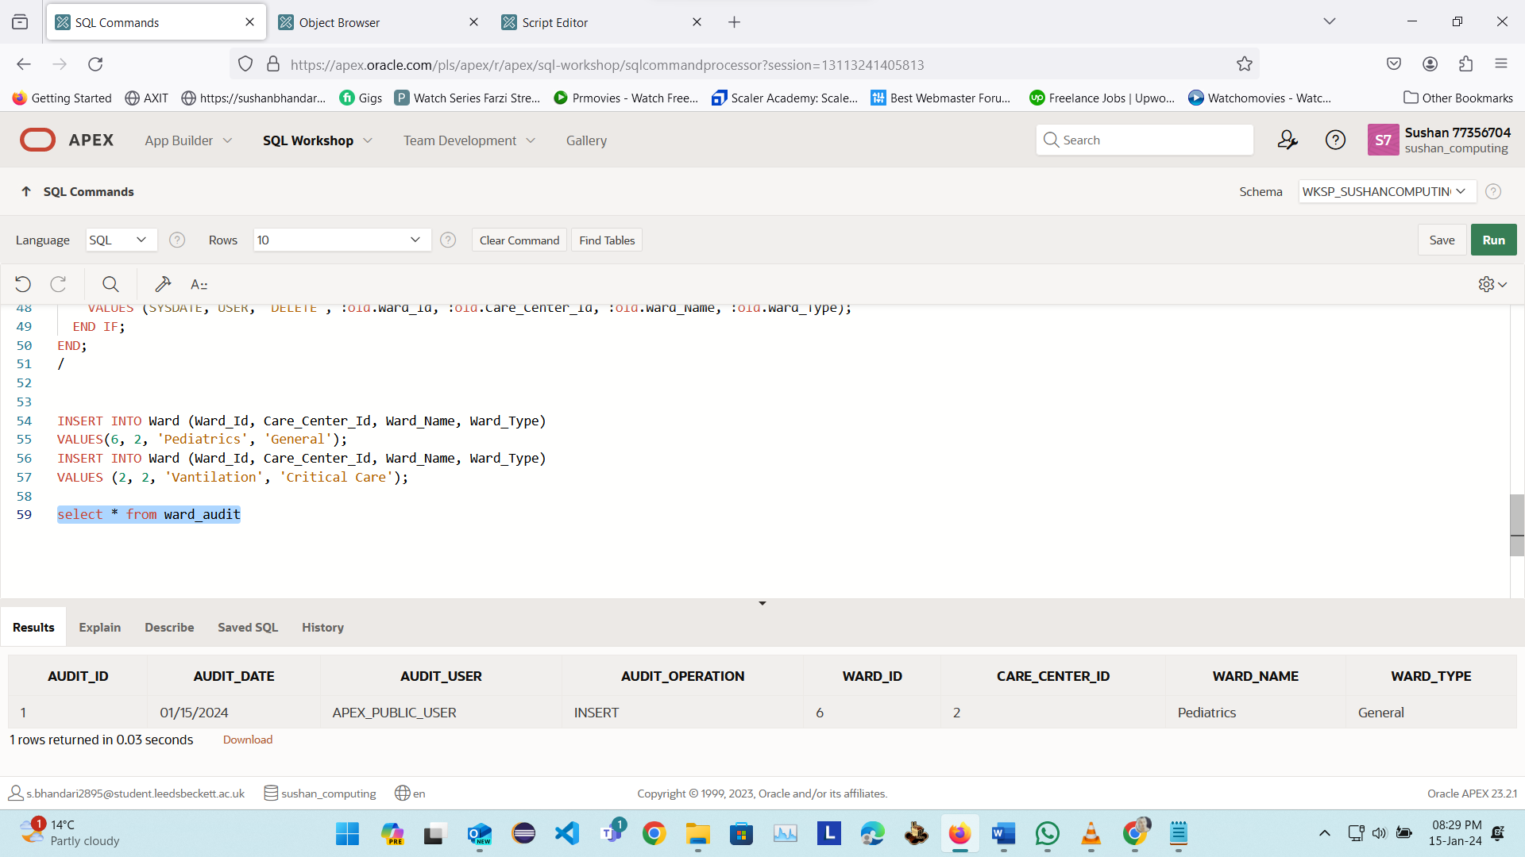

CREATE TABLE Ward_Audit (
Audit_Id NUMBER ,
AUDIT_DATE DATE,
AUDIT_USER VARCHAR2(20),
AUDIT_OPERATION VARCHAR2(20),
Ward_Id NUMBER,
Care_Center_Id NUMBER,
Ward_Name VARCHAR2(50),
Ward_Type VARCHAR2(50)
);

drop table ward_audit

CREATE OR REPLACE TRIGGER trig_audit_ward
BEFORE INSERT ON Ward_Audit
FOR EACH ROW
DECLARE
vAuditID NUMBER(5);
BEGIN

SELECT MAX(NVL(Audit_ID, 0)) + 1 INTO vAuditID FROM Ward_Audit;

IF vAuditID IS NULL THEN
:NEW.Audit_ID := 1;
ELSE
:NEW.Audit_ID := vAuditID;
END IF;
END;
/

CREATE OR REPLACE TRIGGER trigger_audit_ward_trial
AFTER INSERT OR UPDATE OR DELETE ON Ward
FOR EACH ROW
BEGIN
IF INSERTING THEN
INSERT INTO Ward_Audit ( AUDIT_DATE, AUDIT_USER, AUDIT_OPERATION, Ward_Id, Care_Center_Id, Ward_Name, Ward_Type)
VALUES ( SYSDATE, USER, 'INSERT', :new.Ward_Id, :new.Care_Center_Id, :new.Ward_Name, :new.Ward_Type);
END IF;

IF UPDATING THEN
INSERT INTO Ward_Audit ( AUDIT_DATE, AUDIT_USER, AUDIT_OPERATION, Ward_Id, Care_Center_Id, Ward_Name, Ward_Type)
VALUES ( SYSDATE, USER, 'UPDATE', :old.Ward_Id, :old.Care_Center_Id, :old.Ward_Name, :old.Ward_Type);
END IF;

IF DELETING THEN
INSERT INTO Ward_Audit ( AUDIT_DATE, AUDIT_USER, AUDIT_OPERATION, Ward_Id, Care_Center_Id, Ward_Name, Ward_Type)
VALUES (SYSDATE, USER, 'DELETE', :old.Ward_Id, :old.Care_Center_Id, :old.Ward_Name, :old.Ward_Type);
END IF;
END;
/

INSERT INTO Ward (Ward_Id, Care_Center_Id, Ward_Name, Ward_Type)
VALUES(6, 2, 'Pediatrics', 'General');
INSERT INTO Ward (Ward_Id, Care_Center_Id, Ward_Name, Ward_Type)
VALUES (2, 2, 'Vantilation', 'Critical Care');

select * from ward_audit

Date maintenance (batch update)
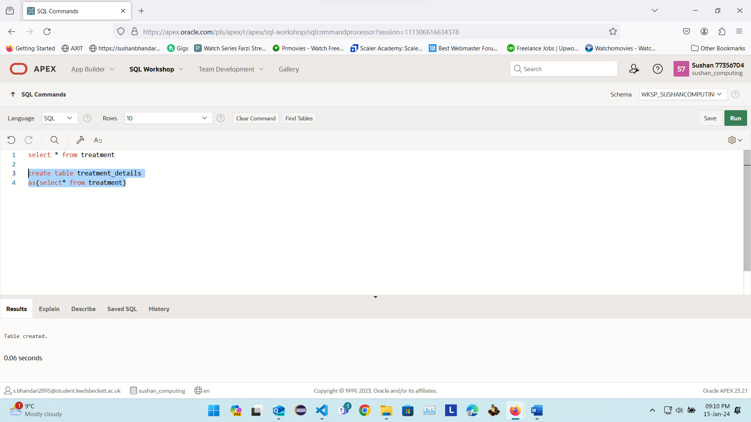
create table treatment_details
as(select* from treatment)

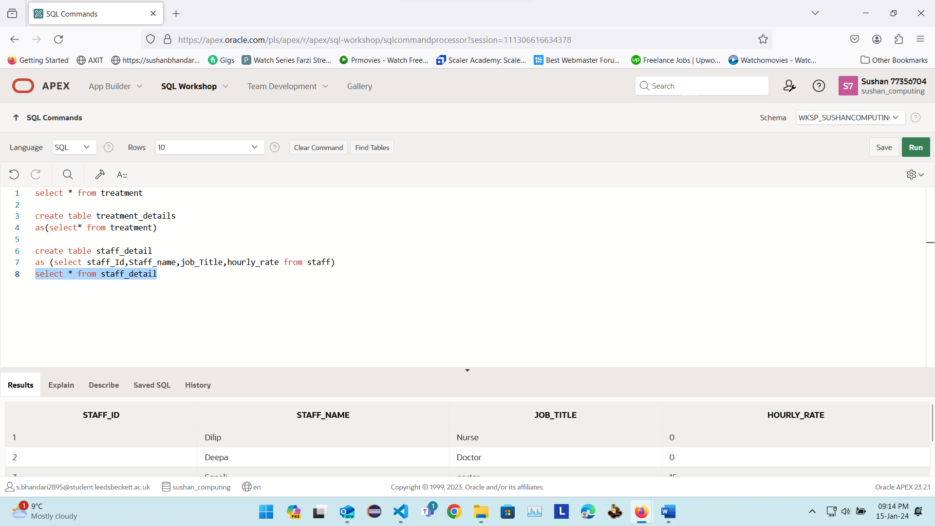
create table staff_detail
as (select staff_Id,Staff_name,job_Title,hourly_rate from staff)
select * from staff_detail
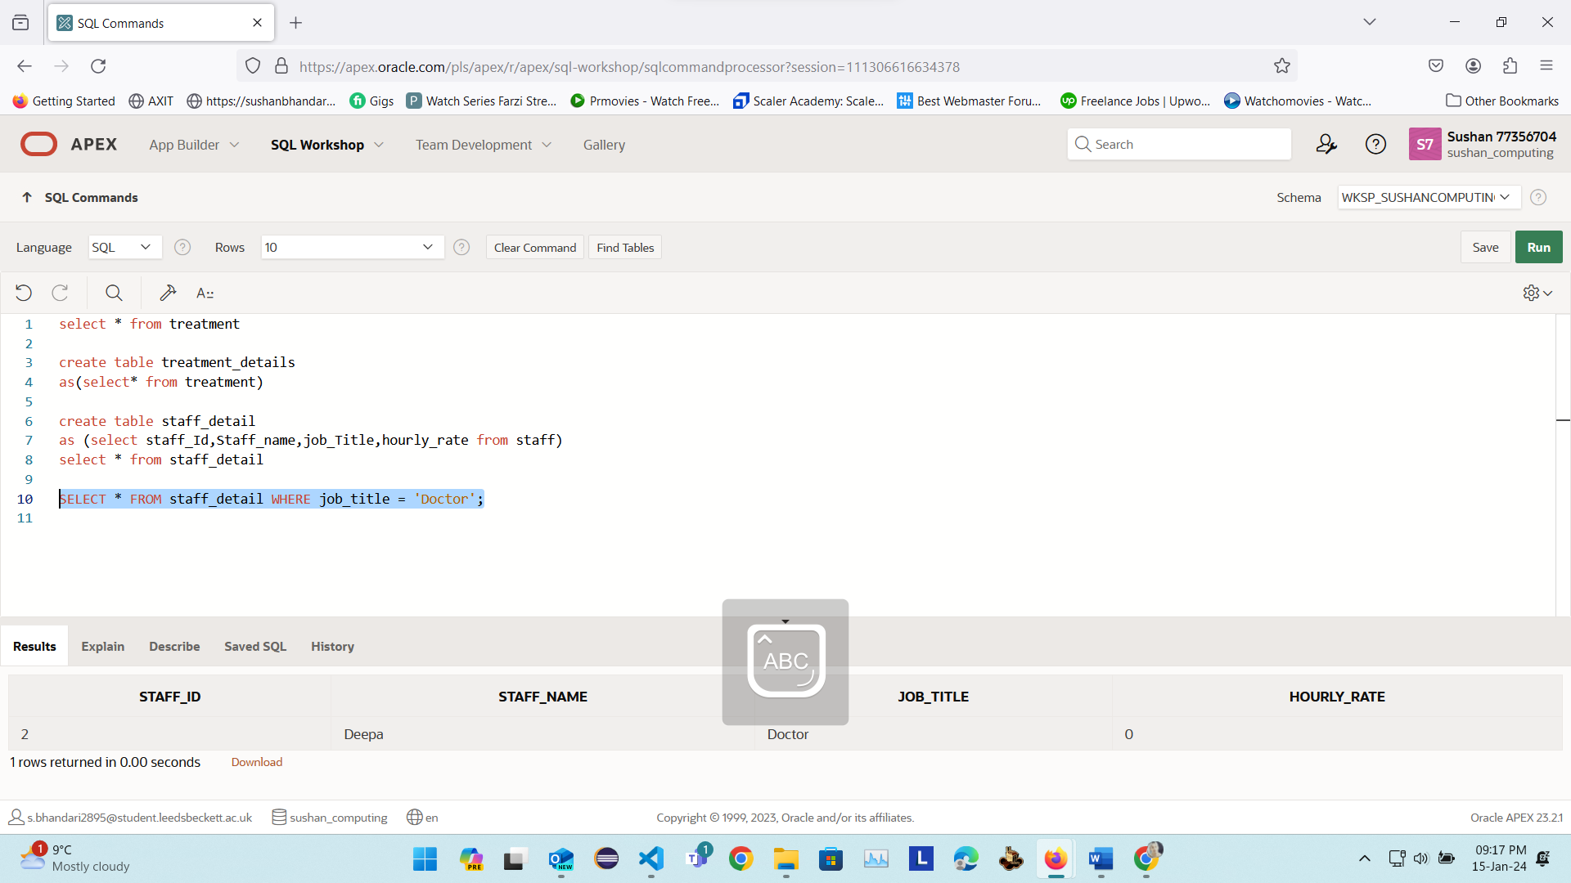
SELECT * FROM staff_detail WHERE job_title = 'Doctor';

4. Bibliography

Oracle (2024) Oracle Database Documentation. [Online]. Austin, TX 78741. Available from: <https://docs.oracle.com/en/database/oracle/oracle-database/index.html> [Accessed 11 jan 2024].
GeeksforGeeks, [2023]. SQL Trigger | Student Database [Online]. Available from: https://www.geeksforgeeks.org/sql-trigger-student-database />
[Accessed 12 January 2024].

tutorialspoint, [2024]. PL/SQL - Functions [Online]. Available from: https://www.tutorialspoint.com/plsql/plsql_functions.htm />
[Accessed 12 January 2024].

5. Appendixes
-- Application Export:
-- Application: 95767
-- Name: LBU_carecenter
-- Date and Time: 15:36 Monday January 15, 2024
-- Exported By: S.BHANDARI2895@STUDENT.LEEDSBECKETT.AC.UK
-- Flashback: 0
-- Export Type: Application Export
-- Pages: 9
-- Items: 35
-- Processes: 16
-- Regions: 16
-- Buttons: 22
-- Shared Components:
-- Logic:
-- Build Options: 1
-- Navigation:
-- Lists: 2
-- Breadcrumbs: 1
-- Entries: 7
-- Security:
-- Authentication: 1
-- Authorization: 1
-- User Interface:
-- Themes: 1
-- Templates:
-- Page: 10
-- Region: 21
-- Label: 7
-- List: 13
-- Popup LOV: 1
-- Calendar: 1
-- Breadcrumb: 1
-- Button: 3
-- Report: 12
-- LOVs: 2
-- PWA:
-- Globalization:
-- Reports:
-- E-Mail:
-- Supporting Objects: Included
-- Version: 23.2.1
-- Instance ID: 63113759365424
--

